Intelligent Summarization of Website Content Using Transformer-Based Models

Academic Year: 2022-2026  Batch Number: 18  Supervisor Name: R.Divyabharathi,M.E  Department: AI&DS | Batch Members: Gopinath.M  Tharanibalan.B

Introduction:
Context & Problem Definition: Websites contain large amounts of text, images, and videos, making it difficult to extract useful information quickly. Existing systems mainly focus on text and ignore multimedia content, leading to incomplete summaries.
Research Objectives: To develop a system that extracts and summarizes multimodal web content using Text-to-Text Transfer Transformer, Bootstrapping Language-Image Pretraining, and Whisper.
Significance of Work: The system reduces information overload and helps users quickly understand web content across different domains.
Literature Review:
Theoretical Framework: Based on Artificial Intelligence, including Natural Language Processing, Computer Vision, and Speech Recognition, using transformer-based models.
Critical Analysis: Existing systems focus only on text and fail to capture full context. This project improves by integrating multimodal data for better summarization.

Methodology: The system takes a website URL, extracts content using web scraping, and separates it into text, images, and video. Text is summarized, images are converted into captions, and video audio is transcribed and summarized. Finally, all outputs are combined into a single coherent summary.
Technical Precision: Uses preprocessing, feature extraction, and AI models to ensure accurate results.
Data Validation: Data is cleaned and evaluated using performance metrics like accuracy and precision.

Work flow:
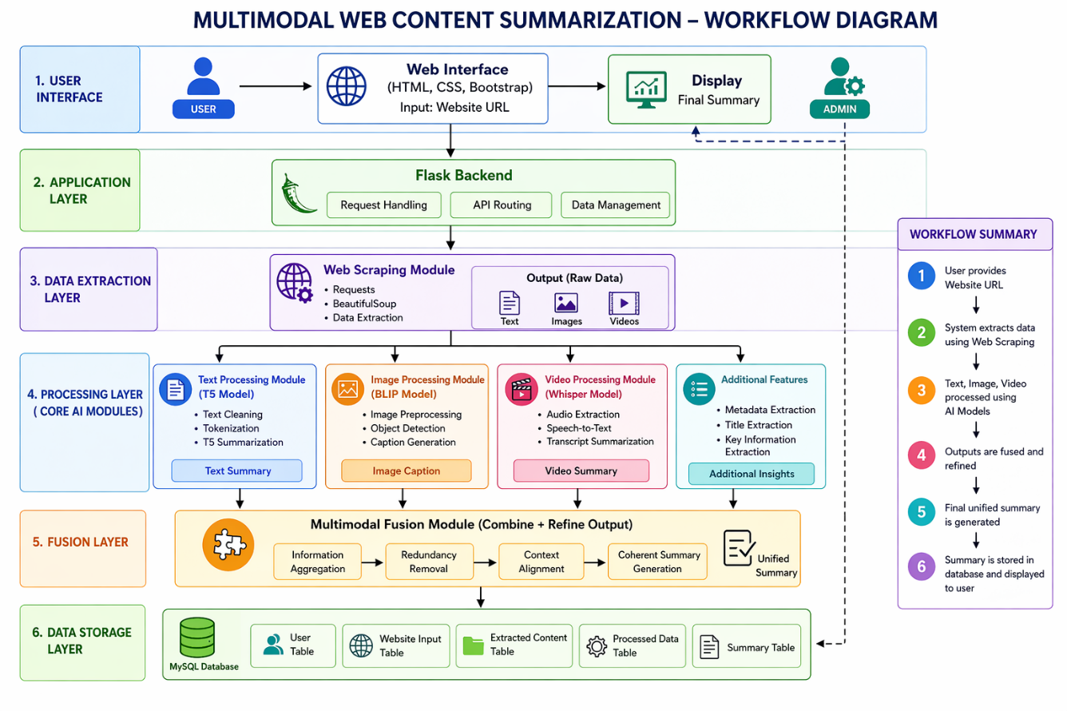

Results & Discussion:

Data Presentation:
Results are shown using charts and tables to evaluate system performance.

Robust Interpretation:

The system produces accurate and meaningful summaries by combining multiple data types.

Hypothesis Validation:

Multimodal summarization improves understanding compared to text-only methods.

Conclusion:

Primary Contributions:
Develops a system that integrates text, image, and video summarization into one framework.
Implications & Limitations:
Improves user understanding but depends on data quality and processing efficiency.
Scope for Future Research:
Future work can include multilingual support and real-time processing.

Key References:

Colin Raffel et al., “Exploring the Limits of Transfer Learning with a Unified Text-to-Text Transformer,” 2020.

Junnan Li et al., “BLIP: Bootstrapping Language-Image Pre-training,” 2022.

Alec Radford et al., “Whisper: Robust Speech Recognition,” 2022.

Jacob Devlin et al., “BERT: Pre-training of Deep Bidirectional Transformers,” 2019

